Corstorphine Bowling Club Events | 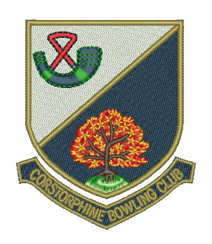

Week Commencing Monday 23 July

Day/Date | Event | Venue | Start Time
Mon 23rd
 | National Championships | Ayr, Northfield | 9.30 am
Club | Hat Night | CBC | 7.00 pm
Tue 24th
 | National Championships | Ayr, Northfield | 9.30 am
Seniors | N & W ‘A’ vs Coltbridge B.C. | CBC | 1.45 pm
 | N & W ‘B’ vs Dean B.C. | Dean | 1.45 pm
 | Hat Day | CBC | 2.00 pm
Wed 25th
 | National Championships | Ayr, Northfield | 9.30 am
Thu 26th
 | National Championships | Ayr, Northfield | 9.30 am
Fri 27th
 | National Championships | Ayr, Northfield | 9.30 am
 | Hat Day | CBC | 1.45 pm
Sat 28th
 | National Championships | Ayr, Northfield | 9.30 am
Gents | Friendly vs Carrickknowe B.C. | Carrickknowe | Noon
Sun 29th
Ladies | Championship Final (C. Bentley vs T. Blair) | CBC | 2.00 pm

