Corstorphine Bowling Club Events | 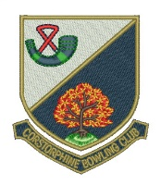

Week Commencing Monday 30 April

Day/Date | Event | Venue | Start Time
Mon 30th
Ladies | EBL vs Carrickknowe B.C. | Carrickknowe | 6.30 pm
Club | Hat Night | CBC | 6.30 pm
Tue 1 May
Seniors | N & W ‘A’ vs Dean B.C. | CBC | 1.45 pm
 | N & W ‘B’ vs Blackhall B.C. | Blackhall | 1.45 pm
 | Hat Day | CBC | 2.00 pm
Wed 2nd
Ladies | Water of Leith vs Currie B.C. | Currie | 2.15 pm
Gents | EBL First XVI vs Dudley B.C. | Dudley | 6.30 pm
 | EBL Second XVI vs Dudley B.C. | CBC | 6.30 pm
 | EBL Third Team vs Maitland B.C. ‘B’ | CBC | 6.30 pm
Fri 4th
 | Hat Day | CBC | 1.45 pm

