Corstorphine Bowling Club Events | 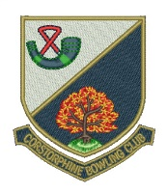

Week Commencing Monday 23 April

Day/Date | Event | Venue | Start Time
Mon 23rd
Club | Hat Night | CBC | 6.30 pm
Tues 24th
 | Hat Day | CBC | 2.00 pm
Wed 25th
Ladies | Water of Leith vs Colinton B.C. | CBC | 2.15 pm
Gents | EBL First XVI vs Second XVI | CBC | 6.15 pm
 | EBL Third Team Rink ‘A’ vs Rink ‘B’ | CBC | 6.15 pm
Fri 27th
 | Hat Day | CBC | 1.45 pm

