Corstorphine Bowling Club Events | 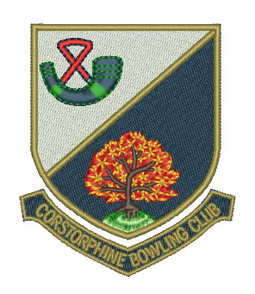

Week Commencing Monday 18 September

Day/Date | Event | Venue | Start Time
Mon 18th
Gents | Murdoch Trophy Final (B. Henaghen vs A. Aitken) | CBC | 4.00 pm
Club | Hat Night | CBC | 6.30 pm
Tue 19th
Seniors | Triples Final (B. Cumming vs A. Macniven) | CBC | 2.00 pm
 | Hat Day | CBC | 2.00 pm
Wed 20th
Seniors | Drawn Pairs Final (J. Connor vs A. Johnston) | CBC | 2.00 pm
Fri 22nd
Ladies | Closing Day | CBC | 2.00 pm
Sat 23rd
 | Closing Day | CBC | 2.00 pm

