Corstorphine Bowling Club Events | 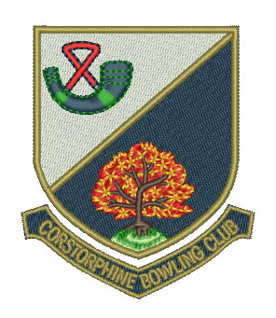

Week Commencing Monday 21 August

Day/Date | Event | Venue | Start Time
Mon 21st
Seniors | ELBA Matt Purdie Final vs West Fife B.A. | Carron & C’shore | Noon
Ladies | EWBA Singles | Craigentinny | 2.00 pm
 | EWBA Quarter-Finals (4 ties) | CBC | 2.00 pm
Club | Hat Night | CBC | 6.30 pm
Tue 22nd
Ladies | Two-Bowl Singles Final (V. Pickard vs J. Meiklejohn) | CBC | 11.00 am
Seniors | N & W ‘A’ vs ‘B’ | CBC | 1.45 pm
 | Hat Day | CBC | 2.00 pm
Seniors | Championship Final (B. Cumming vs B.Brown) | CBC | 3.30 pm
Wed 23rd
Ladies | EWBA Singles Semi-Final (provisional) | Bainfield | 1.30 pm
Gents | Friendly vs Blackhall B.C. | CBC | 6.15 pm
Thu 24th
Club | Ladies vs Gents | CBC | 6.30 pm
Fri 25th
 | Hat Day | CBC | 1.45 pm
Ladies | EWBA Singles Final (provisional) | Braid | 1.30 pm
Gents | President’s Final (K. Logan vs B. Callaghan) | CBC | 5.30 pm
 | Vice-President’s Final (B. Savage vs J. Vaughan) | CBC | 5.30 pm
Ladies | Player Development Session | CBC | 6.30 pm
Sun 27th
Club | Millar Cup | CBC | 2.00 pm

