Corstorphine Bowling Club Events | 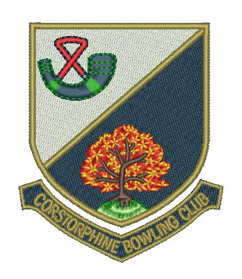

Week Commencing Monday 19 June

Day/Date | Event | Venue | Start Time
Mon 19th
Seniors | ELBA Matt Purdie Trial | Slateford | Noon
 | N & W ‘A’ vs Goldenacre B.C. | Goldenacre | 1.45 pm
 | Hat Day | CBC | 2.00 pm
Ladies | Heather League vs Beechwood B.C. | Home/Away | 2.00 pm
 | Olive Smith Fours vs W’house & Grange B.C. | CBC | 2.00 pm
Seniors | Bowls Scotland District Finals | Mayfield | 2.00 pm
Ladies | EBL vs Tanfield B.C. | Tanfield | 6.45 pm
Club | Hat Night | CBC | 7.00 pm
Tue 20th
Seniors | N & W ‘A’ vs ‘B’ | CBC | 1.45 pm
Ladies | East of Scotland Singles | Juniper Green | 2.00 pm
Gents | Bowls Scotland District Finals | Currie | 6.30 pm
Wed 21st
Gents | EBL First XVI vs Blackhall B.C. | Blackhall | 6.45 pm
 | EBL Second XVI vs Wardie B.C. | CBC | 6.45 pm
 | EBL Third Team vs Wardie B.C. | Wardie | 6.45 pm
Thu 22nd
Seniors | RMBA vs Mayfield B.C. | CBC | 1.30 pm
 | N & W Knockout Pairs vs Goldenacre B.C. | Goldenacre | 1.45 pm
Ladies | East of Scotland Pairs | Coltbridge | 2.00 pm
 | East of Scotland Triples | Coltbridge | 2.00 pm
Fri 23rd
Seniors | N&W Knockout Fours vs Queensberry B.C. | Queensberry | 1.45 pm
 | Hat Day | CBC | 1.45 pm
Ladies | Water of Leith Championships (3 ties) | CBC | 2.00 pm
Seniors | ELBA Fours | Parkside | 2.00 pm
Gents | EBL Edinburgh Cup vs Slateford B.C. | CBC | 6.45 pm
Sun 25th
Ladies | Bowls Scotland District Finals | Colinton | 11.00 am
Mixed | ELBA Mixed Rink vs Bainfield B.C. | Gorgie Mills | 6.30 pm

