Corstorphine Bowling Club Events | 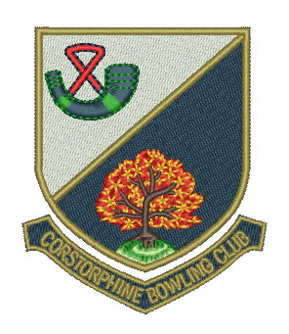

Week Commencing Monday 1 May

Day/Date | Event | Venue | Start Time
Mon 1st
 | Hat Day | CBC | 2.00 pm
Club | Hat Night | CBC | 6.30 pm
Tue 2nd
Seniors | N & W ‘A’ vs Dean B.C. | Dean | 1.45 pm
 | N & W ‘B’ vs Willowbrae B.C. | CBC | 1.45 pm
Wed 3rd
Ladies | Water of Leith vs Juniper Green B.C. | CBC | 2.15 pm
Gents | EBL First XVI vs Blackhall B.C. | CBC | 6.30 pm
 | EBL Second XVI vs Wardie B.C. | Wardie | 6.30 pm
 | EBL Third Team vs Wardie B.C. | CBC | 6.30 pm
Thu 4th
Ladies | Friendly vs Leith B.C. | Leith | 2.00 pm
Fri 5th
 | Hat Day | CBC | 1.45 pm

